[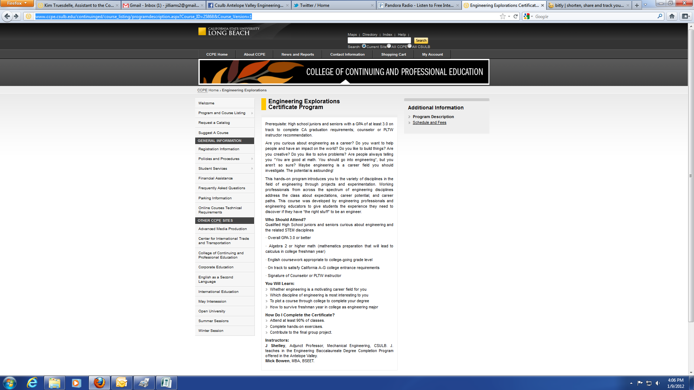](http://www.ccpe.csulb.edu/continuinged/course_listing/programdescription.aspx?Course_ID=25868&Course_Version=1)

**HOW TO REGISTER:**

1. Go to <http://www.facebook.com/csulb.av.engineering>.
2. Click on the link in the posting for “Engineering Explorations”
3. Click on “Schedules and Fees” on the right side menu of the page that opens.
4. The first item that appears is for “Engineering Explorations.” Click on the “Add Section to Cart” button to begin the registration process.

**QUESTIONS**

Contact Jill Williams at [Jill.Williams@csulb.edu](mailto:Jill.Williams@csulb.edu) or (661) 723-6429, ext. 103

**COURSE DETAILS**

**Dates:**Jan 30–May 14

**Time:**   
4:00pm–7:00pm

**Location:**   
Lancaster University Center  
45356 Division Street   
Lancaster, CA 93535